Performance Testing
Date | 06 Nov 2025
Team ID | FE7F7B420961141A91F48E734450581D
Project Name | CRM Application for Jewel Management - (Developer)
Maximum Marks | 2 Marks

User Creation :

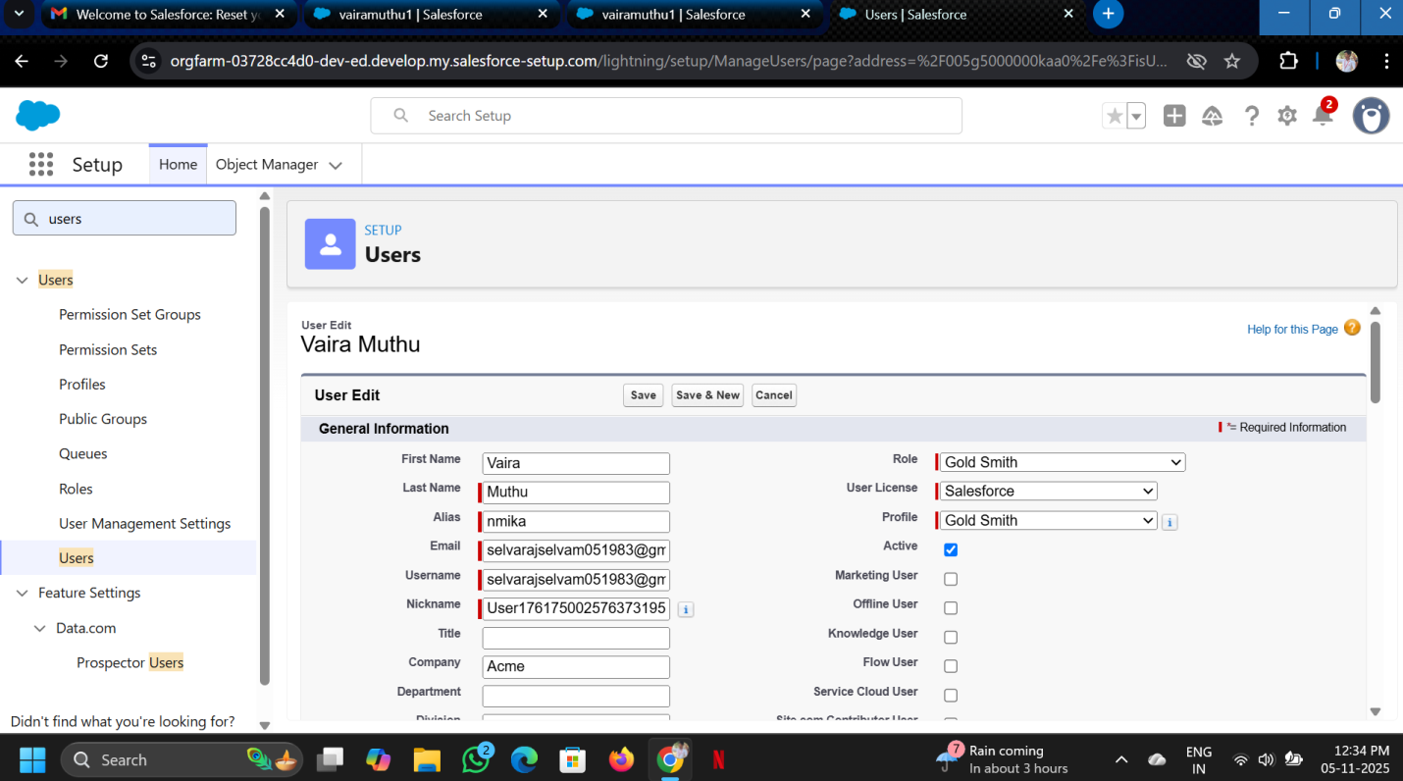

Assign Incident to User :
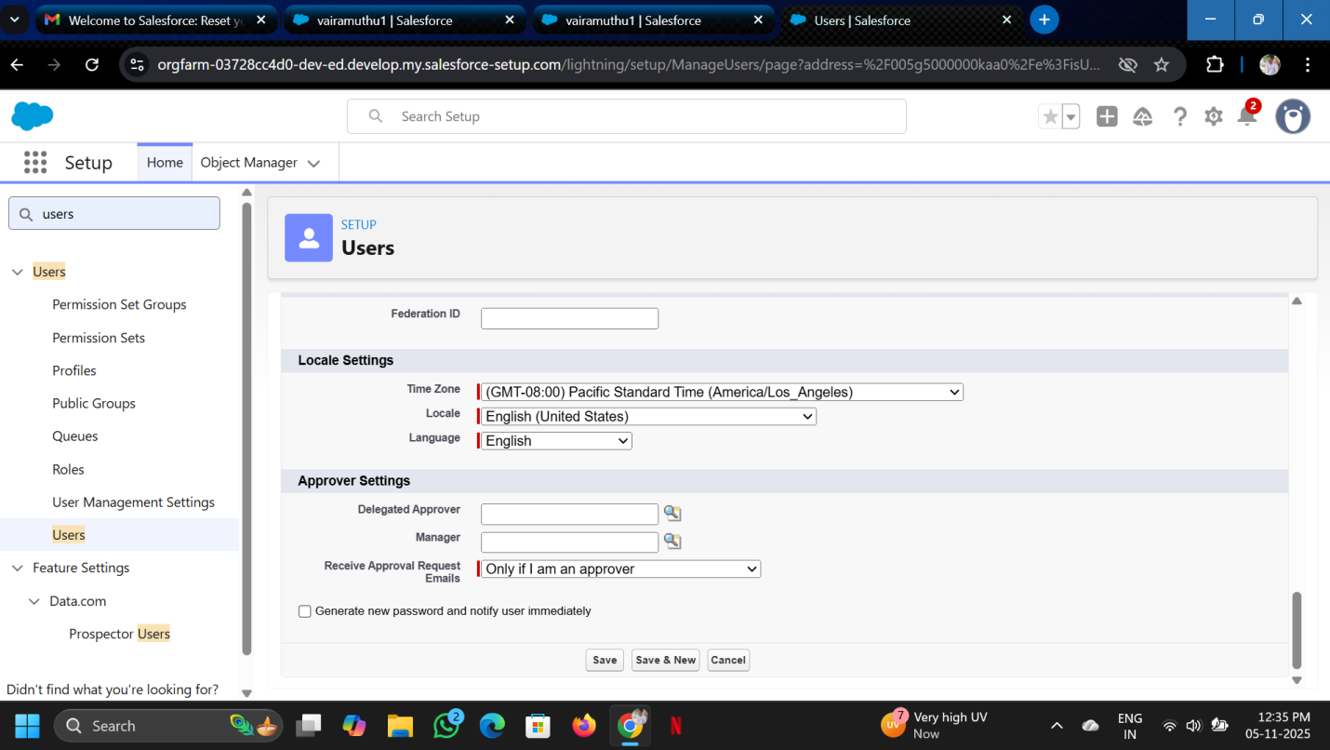

User create complete :

